SURGERY PRICES

DOG SPAY  Up to 100 lbs……..$275  101 – 125 lbs……..$325  126 – 150 lbs……..$350  151 – 175 lbs….....$375  Over 176 lbs……….$400  Pregnant/In heat..+$75 | DOG NEUTER  Up to 100 lbs……..$200  101 – 125 lbs……..$250  126 – 150 lbs……..$275  151 – 175 lbs….....$300  Over 176 lbs…….…$325  Cryptorchid.........+$75/side | CATS  Spay….......…...........$120  Neuter....................$75  Feral.......................$50  Cryptorchid..........+$25/side Pregnant/In heat..+$25

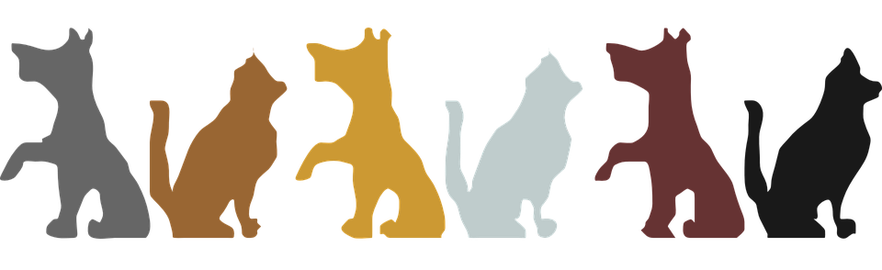

ADDITIONAL FEES

  - Pyometra difficulty fee (dogs & cats).........$100
  - Bordetella vaccination (dogs).......................$20
  - FeLV/FIV combo test (cats)...........................$25
  - Flea/Tick control (dogs & cats).....................$13
  - Umbilical hernia repair (dogs)......................$45
  - Umbilical hernia repair (cats).......................$15
  - Microchip (dogs & cats)................................$20
  - Dewormer.....................................PRICE VARIES
  - E-Collar..........................................PRICE VARIES

  - All spay/neuter surgeries require a non-refundable deposit of $50, which is applied to surgery cost.
  - CATS Fees always include rabies & distemper vaccines, nail trim, ear cleaning, SQ fluids, pain medicine.
  - DOG fees always include rabies & distemper vaccines, nail trim, ear cleaning, SQ fluids, pain medicine.

